Complementary Angles
# Source: AI Source: Provided by: [Data Path: Persons Table -> ID Column: 1, Name_En Column: Motasem Essam] -> From: [ChatGPT] on [7/25/2026]
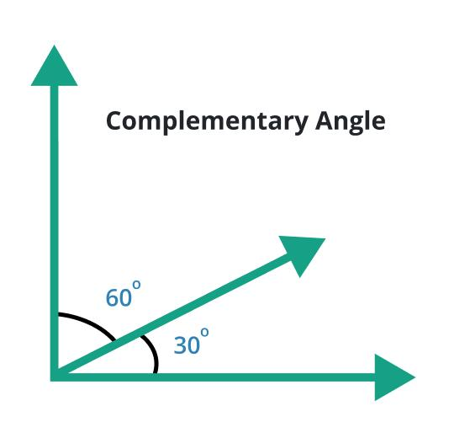
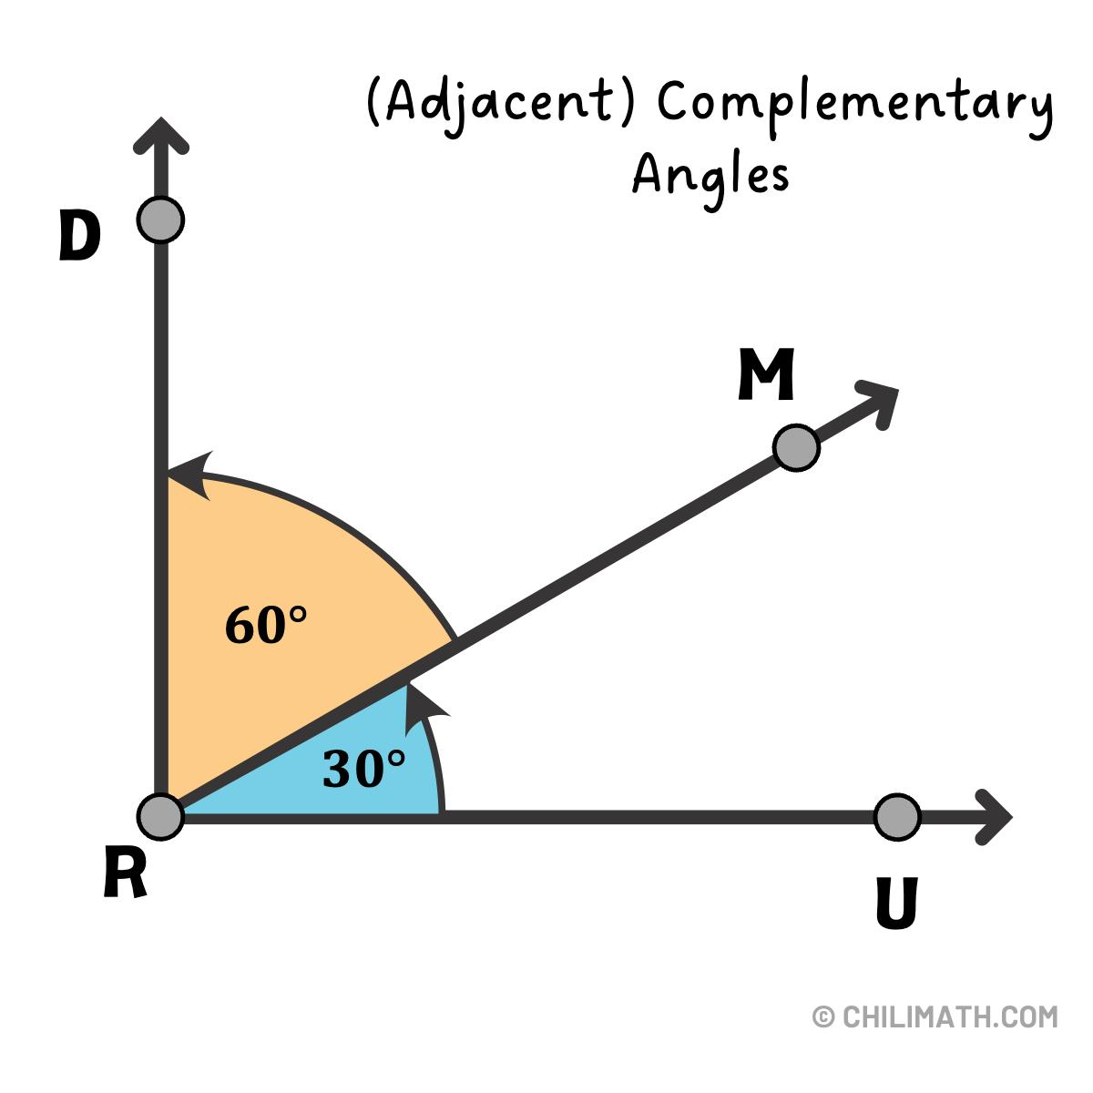
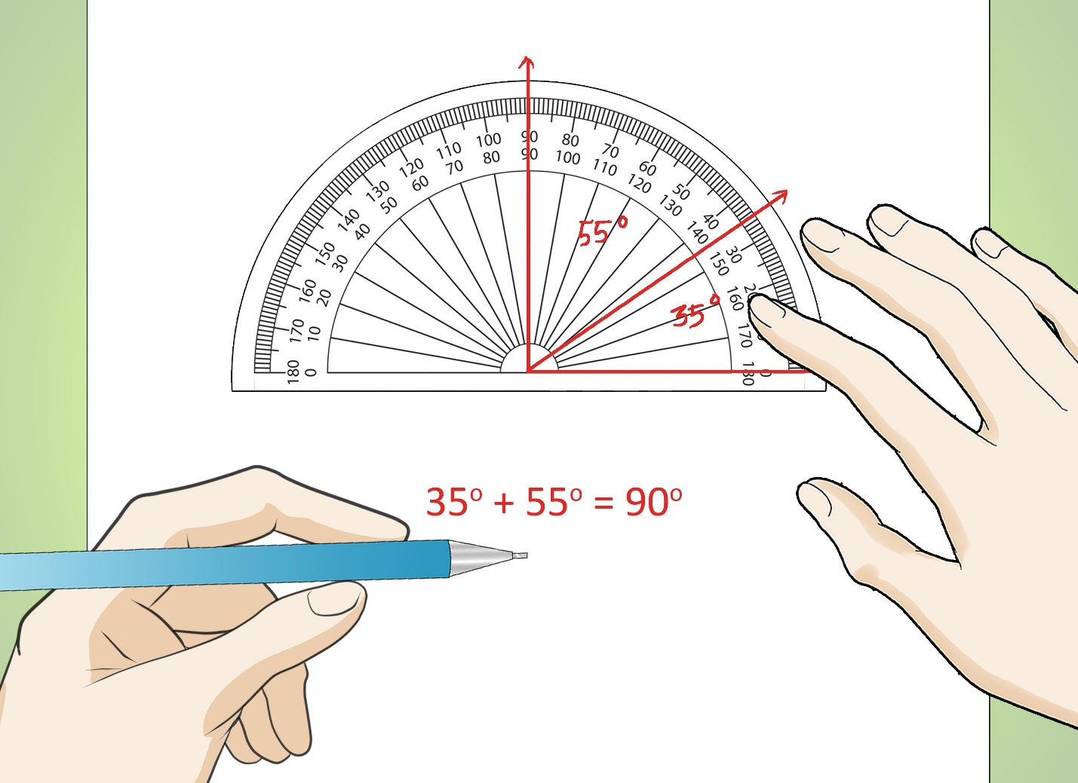
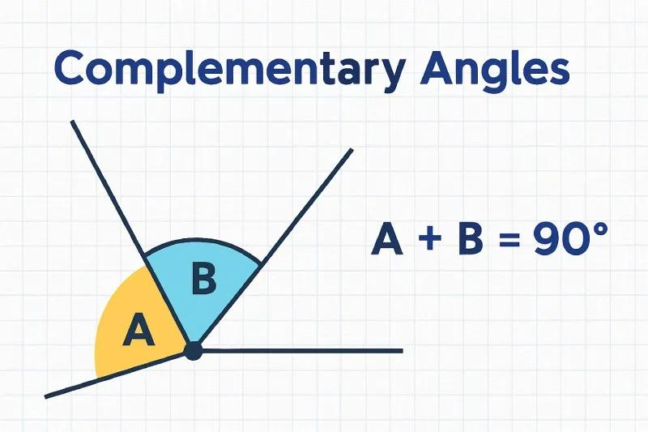
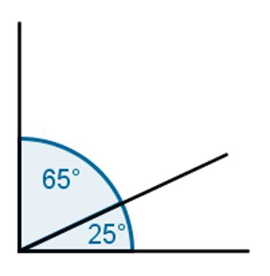
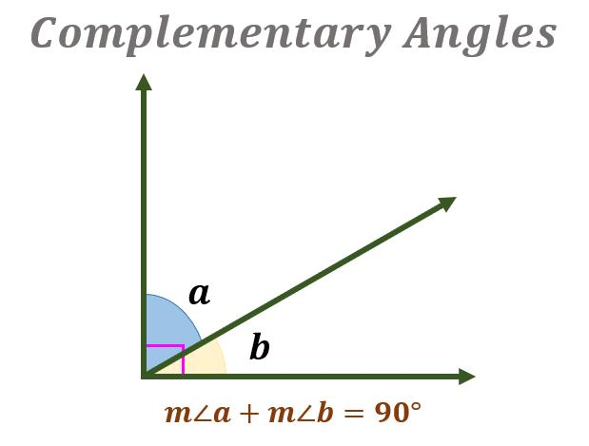

Definition
# Source: AI Source: Provided by: [Data Path: Persons Table -> ID Column: 1, Name_En Column: Motasem Essam] -> From: [ChatGPT] on [7/25/2026]
Complementary Angles are two angles whose measures add up to exactly (90^\circ).
They do not necessarily need to be adjacent; they only need to satisfy the sum relationship:
$$m∠A+m∠B={90}^{∘}$$
A complementary angle pair forms a right angle when the two angles are placed next to each other.

Characteristics
# Source: AI Source: Provided by: [Data Path: Persons Table -> ID Column: 1, Name_En Column: Motasem Essam] -> From: [ChatGPT] on [7/25/2026]
Complementary angles:
- Have a total measure of:
$${90}^{∘}$$
- Can be adjacent or non-adjacent.
- May have different angle measures.
- Each angle is called the complement of the other.
- Both angles must be acute (unless one angle is (0^\circ)).
- Are related to right angles.

Illustration

Adjacent Complementary Angles
# Source: AI Source: Provided by: [Data Path: Persons Table -> ID Column: 1, Name_En Column: Motasem Essam] -> From: [ChatGPT] on [7/25/2026]
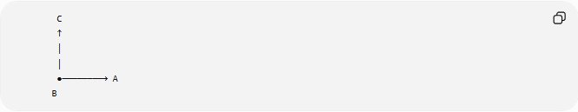
C
↑
│
│
●────────→ A
B
The two angles together form:
$${90}^{∘}$$
Example:
$${30}^{∘}+{60}^{∘}={90}^{∘}$$

Non-Adjacent Complementary Angles
# Source: AI Source: Provided by: [Data Path: Persons Table -> ID Column: 1, Name_En Column: Motasem Essam] -> From: [ChatGPT] on [7/25/2026]
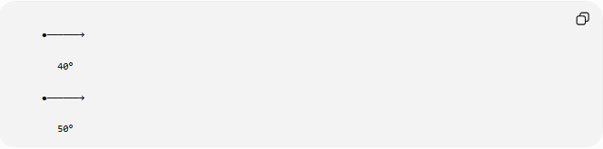
●──────→

40°

●──────→

50°
Although they are separate, their measures satisfy:
$${40}^{∘}+{50}^{∘}={90}^{∘}$$

Mathematical Representation
# Source: AI Source: Provided by: [Data Path: Persons Table -> ID Column: 1, Name_En Column: Motasem Essam] -> From: [ChatGPT] on [7/25/2026]
If two angles are:
$$∠A$$
and
$$∠B$$
then they are complementary if:
$$m∠A+m∠B={90}^{∘}$$
or:
$$θ_{1}+θ_{2}=\frac{π}{2}$$
in radians.

Examples
# Source: AI Source: Provided by: [Data Path: Persons Table -> ID Column: 1, Name_En Column: Motasem Essam] -> From: [ChatGPT] on [7/25/2026]
Example 1
Given:
$$∠A={35}^{∘}$$
Find its complement:
$${90}^{∘}-{35}^{∘}={55}^{∘}$$
Therefore:
$$∠B={55}^{∘}$$

Example 2
Given:
$$∠A={72}^{∘}$$
The complementary angle is:
$${90}^{∘}-{72}^{∘}={18}^{∘}$$

Common Complementary Angle Pairs
# Source: AI Source: Provided by: [Data Path: Persons Table -> ID Column: 1, Name_En Column: Motasem Essam] -> From: [ChatGPT] on [7/25/2026]
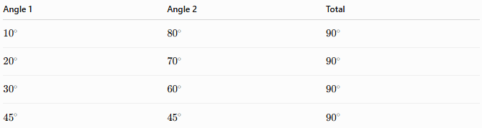
Angle 1 | Angle 2 | Total
$${10}^{∘}$$ | $${80}^{∘}$$ | $${90}^{∘}$$
$${20}^{∘}$$ | $${70}^{∘}$$ | $${90}^{∘}$$
$${30}^{∘}$$ | $${60}^{∘}$$ | $${90}^{∘}$$
$${45}^{∘}$$ | $${45}^{∘}$$ | $${90}^{∘}$$

Properties of Complementary Angles
# Source: AI Source: Provided by: [Data Path: Persons Table -> ID Column: 1, Name_En Column: Motasem Essam] -> From: [ChatGPT] on [7/25/2026]
1. Sum Property
The defining property is:
$$θ_{1}+θ_{2}={90}^{∘}$$

2. Complement of an Angle
For any angle:
$$θ$$
its complement is:
$${90}^{∘}-θ$$
Example:
$${90}^{∘}-{25}^{∘}={65}^{∘}$$

3. Relationship with Right Angles
When two complementary angles are adjacent:
$$∠A+∠B={90}^{∘}$$
they form a right angle.

4. Both Angles Are Acute
Examples:
$${30}^{∘}$$
and
$${60}^{∘}$$
are both acute.

Complementary Angles in Geometry
# Source: AI Source: Provided by: [Data Path: Persons Table -> ID Column: 1, Name_En Column: Motasem Essam] -> From: [ChatGPT] on [7/25/2026]
Complementary angles appear in:
Right Triangles
A right triangle contains:
- One right angle:
$${90}^{∘}$$
- Two complementary acute angles:
$$A+B={90}^{∘}$$
Example:
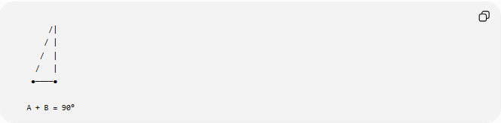

/|
/ |
/ |
/ |
●────●

A + B = 90°

Real-World Examples
# Source: AI Source: Provided by: [Data Path: Persons Table -> ID Column: 1, Name_En Column: Motasem Essam] -> From: [ChatGPT] on [7/25/2026]
Complementary angles appear in:
- The corner of a square divided by a diagonal.
- A ladder leaning against a wall.
- Navigation directions.
- Architectural designs.
- Engineering drawings.
- Machine parts forming right angles.

Applications
# Source: AI Source: Provided by: [Data Path: Persons Table -> ID Column: 1, Name_En Column: Motasem Essam] -> From: [ChatGPT] on [7/25/2026]
Complementary angles are used in:
- Plane Geometry
- Coordinate Geometry
- Trigonometry
- Engineering
- Architecture
- Construction
- Surveying
- CAD (Computer-Aided Design)
- Robotics
- Computer Graphics

Advantages
# Source: AI Source: Provided by: [Data Path: Persons Table -> ID Column: 1, Name_En Column: Motasem Essam] -> From: [ChatGPT] on [7/25/2026]
Studying complementary angles helps to:
- Find missing angle measures.
- Solve triangle problems.
- Understand right-angle relationships.
- Apply trigonometric concepts.
- Analyze geometric constructions.

Limitations
# Source: AI Source: Provided by: [Data Path: Persons Table -> ID Column: 1, Name_En Column: Motasem Essam] -> From: [ChatGPT] on [7/25/2026]
Complementary angles:
- Must add to exactly:
$${90}^{∘}$$
- Are not complementary if their sum is:
  - ${180}^{∘}$
  - ${360}^{∘}$
  - Any other value

Comparison with Other Angle Relationships
# Source: AI Source: Provided by: [Data Path: Persons Table -> ID Column: 1, Name_En Column: Motasem Essam] -> From: [ChatGPT] on [7/25/2026]
Relationship | Condition
Complementary Angles | Sum $={90}^{∘}$
Supplementary Angles | Sum $={180}^{∘}$
Adjacent Angles | Share vertex and one side
Vertical Angles | Opposite angles formed by intersecting lines
Congruent Angles | Equal angle measures

Key Points
# Source: AI Source: Provided by: [Data Path: Persons Table -> ID Column: 1, Name_En Column: Motasem Essam] -> From: [ChatGPT] on [7/25/2026]
- Complementary Angles have a sum of:
$${90}^{∘}$$
- Formula:
$$m∠A+m∠B={90}^{∘}$$
- They may be adjacent or separate.
- Adjacent complementary angles form a right angle.
- The complement of an angle is:
$${90}^{∘}-θ$$

Conclusion
# Source: AI Source: Provided by: [Data Path: Persons Table -> ID Column: 1, Name_En Column: Motasem Essam] -> From: [ChatGPT] on [7/25/2026]
Complementary Angles are pairs of angles whose measures add up to exactly ${90}^{∘}$. They are fundamental in geometry because they describe how angles combine to form right angles and help solve unknown angle measurements. Complementary angles are especially important in right triangles, trigonometry, engineering, architecture, construction, surveying, CAD, robotics, and computer graphics, where perpendicular relationships and precise angular measurements are required.

